

**OOP (Object Oriented Programming) Lab**

**LAB REPORT # 1**

**Semester**: 2ndSemester

**Section**: B

**Submitted To:**

**Irfan Haider**

**Submitted By:**

**Name**: Hafiz Haseeb Naeem

**Roll No**: 22-CS-030

**Code:**

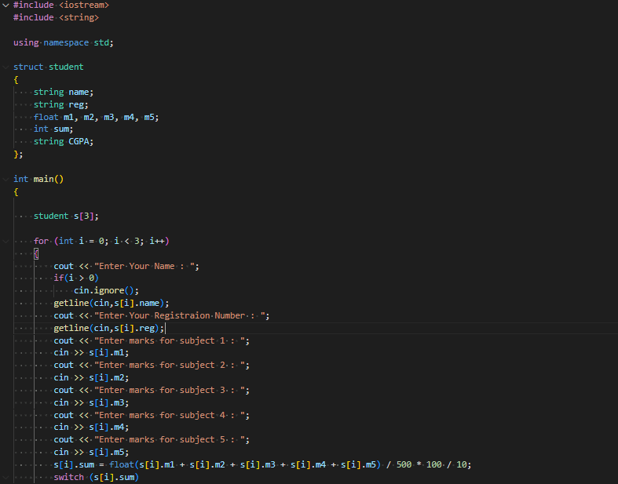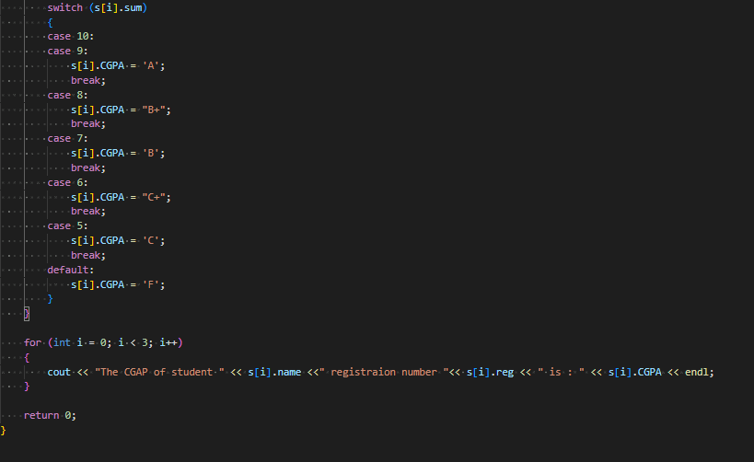

**Output:**

